CS 3185
Homework 1
Todd Carter
V01187982
9-7-2025

Section 1.1

18) Prove S1 x (S2 U S3) = (S1 x S2) U (S1 x S3)

Proof:

First, show that S1 x (S2 U S3) C (S1 x S2) U (S1 x S3).

Let (x, y) be any element of S1 x (S2 U S3).
We will show that (x, y) ϵ (S1 x S2) U (S1 x S3).

Since (x, y) is in S1 x (S2 U S3), we know that x ϵ S1 and y ϵ (S2 U S3).
So either y ϵ S2 or y ϵ S3.

Then, (x, y) ϵ (S1 x S2) if y ϵ S2 and (x, y) ϵ (S1 x S3) if y ϵ S3.

This shows that S1 x (S2 U S3) C (S1 x S2) U (S1 x S3).

Second, we show that (S1 x S2) U (S1 x S3) C S1 x (S2 U S3).

Let (w, z) be any element of (S1 x S2) U (S1 X S3).
We will show that (w, z) ϵ S1 x (S2 U S3).

We know w ϵ S1 when (w, z) ϵ (S1 x S2)
and w ϵ S1 when (w, z) ϵ (S1 x S3).
So w ϵ S1.

We know z ϵ S2 when (w, z) ϵ (S1 x S2) and z ϵ S3 when (w, z) ϵ (S1 x S3).
So z ϵ S2 U S3.

This shows that (w, z) ϵ S1 x (S2 U S3).

Which then shows that (S1 x S2) U (S1 x S3) C S1 x (S2 U S3)

So, we have shown that

S1 x (S2 U S3) C (S1 x S2) U (S1 x S3)

And

(S1 x S2) U (S1 x S3) C S1 x (S2 U S3).

So, therefore, since each is a subset of the other, this means that

S1 x (S2 U S3) = (S1 x S2) U (S1 x S3).

42) Show that √3 is irrational.

Proof:

Assume to reach a contradiction in that a and b are integers and that √3 = a/b.
Also assume that a and b have no common factors and are not both divisible by 3.

Then, a/b = √3

a² / b² = 3

a² = 3b²

So, a² is divisible by 3, which means a is divisible by 3.

Let a = 3k.

So,

3b² = a² = (3k)² = 9k² which means b² = 3k².

This means b² is divisible by 3, which contradicts a and b having no common factors, and thus proves this by contradiction.

43) Prove or disprove the following statements:

a) The sum of an irrational and rational number must be irrational.

Proof:

Proving by contradiction, let a b rational and b be irrational.

Let

c = a + b

be a rational statement.

This means

b = c – a

which is not rational and therefore a contradiction, and thus proves the statement true.

b) The sum of two positive, irrational numbers must be irrational.

Proof:

Proving by contradiction, let a = 2 + √2 and b = 2 - √2, which are both positive, irrational numbers.

This leads

a + b = 4 + 0

which is rational, and therefore a contradiction that proves the statement false.

c) The product of a nonzero rational and an irrational number must be irrational.

Proof:

Proving by contradiction, let a be a rational, non-zero number and b be an irrational, non-zero number. Also assume

c = ab

is also rational.

Since c = ab is rational, then

b = c/a

is also rational.

This is a contradiction, as b was stated to be irrational, which proves the statement true.

Section 1.2

5) Let L = {ab, aa, baa}. Which of the strings are in L*? Which are in L⁴?

The strings in L* are:

L* = {abaabaaabaa, aaaabaaaa, baaaaabaa}

There are no strings in L⁴.

14) Find grammars for Σ = {a, b} that generate sets of:

c) all strings with no more than three a’s.

S = T | UTU | λ
T = a | aa | aaa | λ
U = bU | λ

d) all strings with at least three a’s.

S = T | UTU
T = aaa | aaaT
U = bU | λ

f) all strings with an even number of b’s.

S = SbSbS | T | λ
T = aT | λ

17) For each of the following languages, find a grammar that generates it:

- L1 = { a^{n}b^{m} : n >= 0, m < n }

S = TU
T = aT | a | 1
U = aUb | λ

- L2 = { a^{3n}b^{2n} : n >= 2 }

S = TT | ST
T = aaabb

e) L1L2

S = S1S2

$$S1= \left\{\begin{aligned}S=TU \\ T=aT \left| a \right|1 \\ U=aUb | λ\end{aligned}\right.$$

$$S2= \left\{\begin{aligned}V=WW | VW \\ W=aaabb\end{aligned}\right.$$

f) L1 U L2

S = S1 | S2

$$S1= \left\{\begin{aligned}S=TU \\ T=aT \left| a \right|1 \\ U=aUb | λ\end{aligned}\right.$$

$$S2= \left\{\begin{aligned}V=WW | VW \\ W=aaabb\end{aligned}\right.$$

Question:
Find a grammar for L = {w in {a,b}* : n_{a}(w) > n_{b}(w)}

S = a | S | ST
T = aab | aabT

Section 2.1

3) For Σ = {a, b} construct DFA’s that accept the sets consisting of:

- all strings of even length.

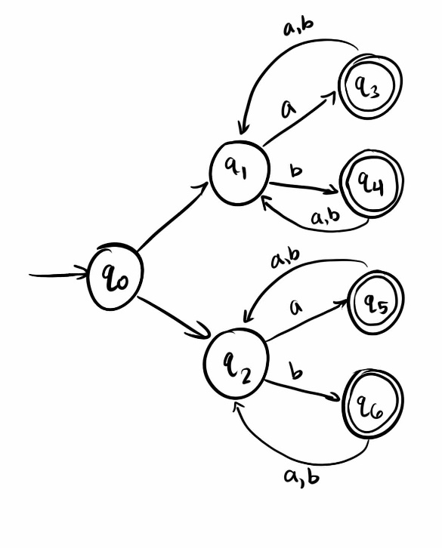

- all strings of length greater than 5.

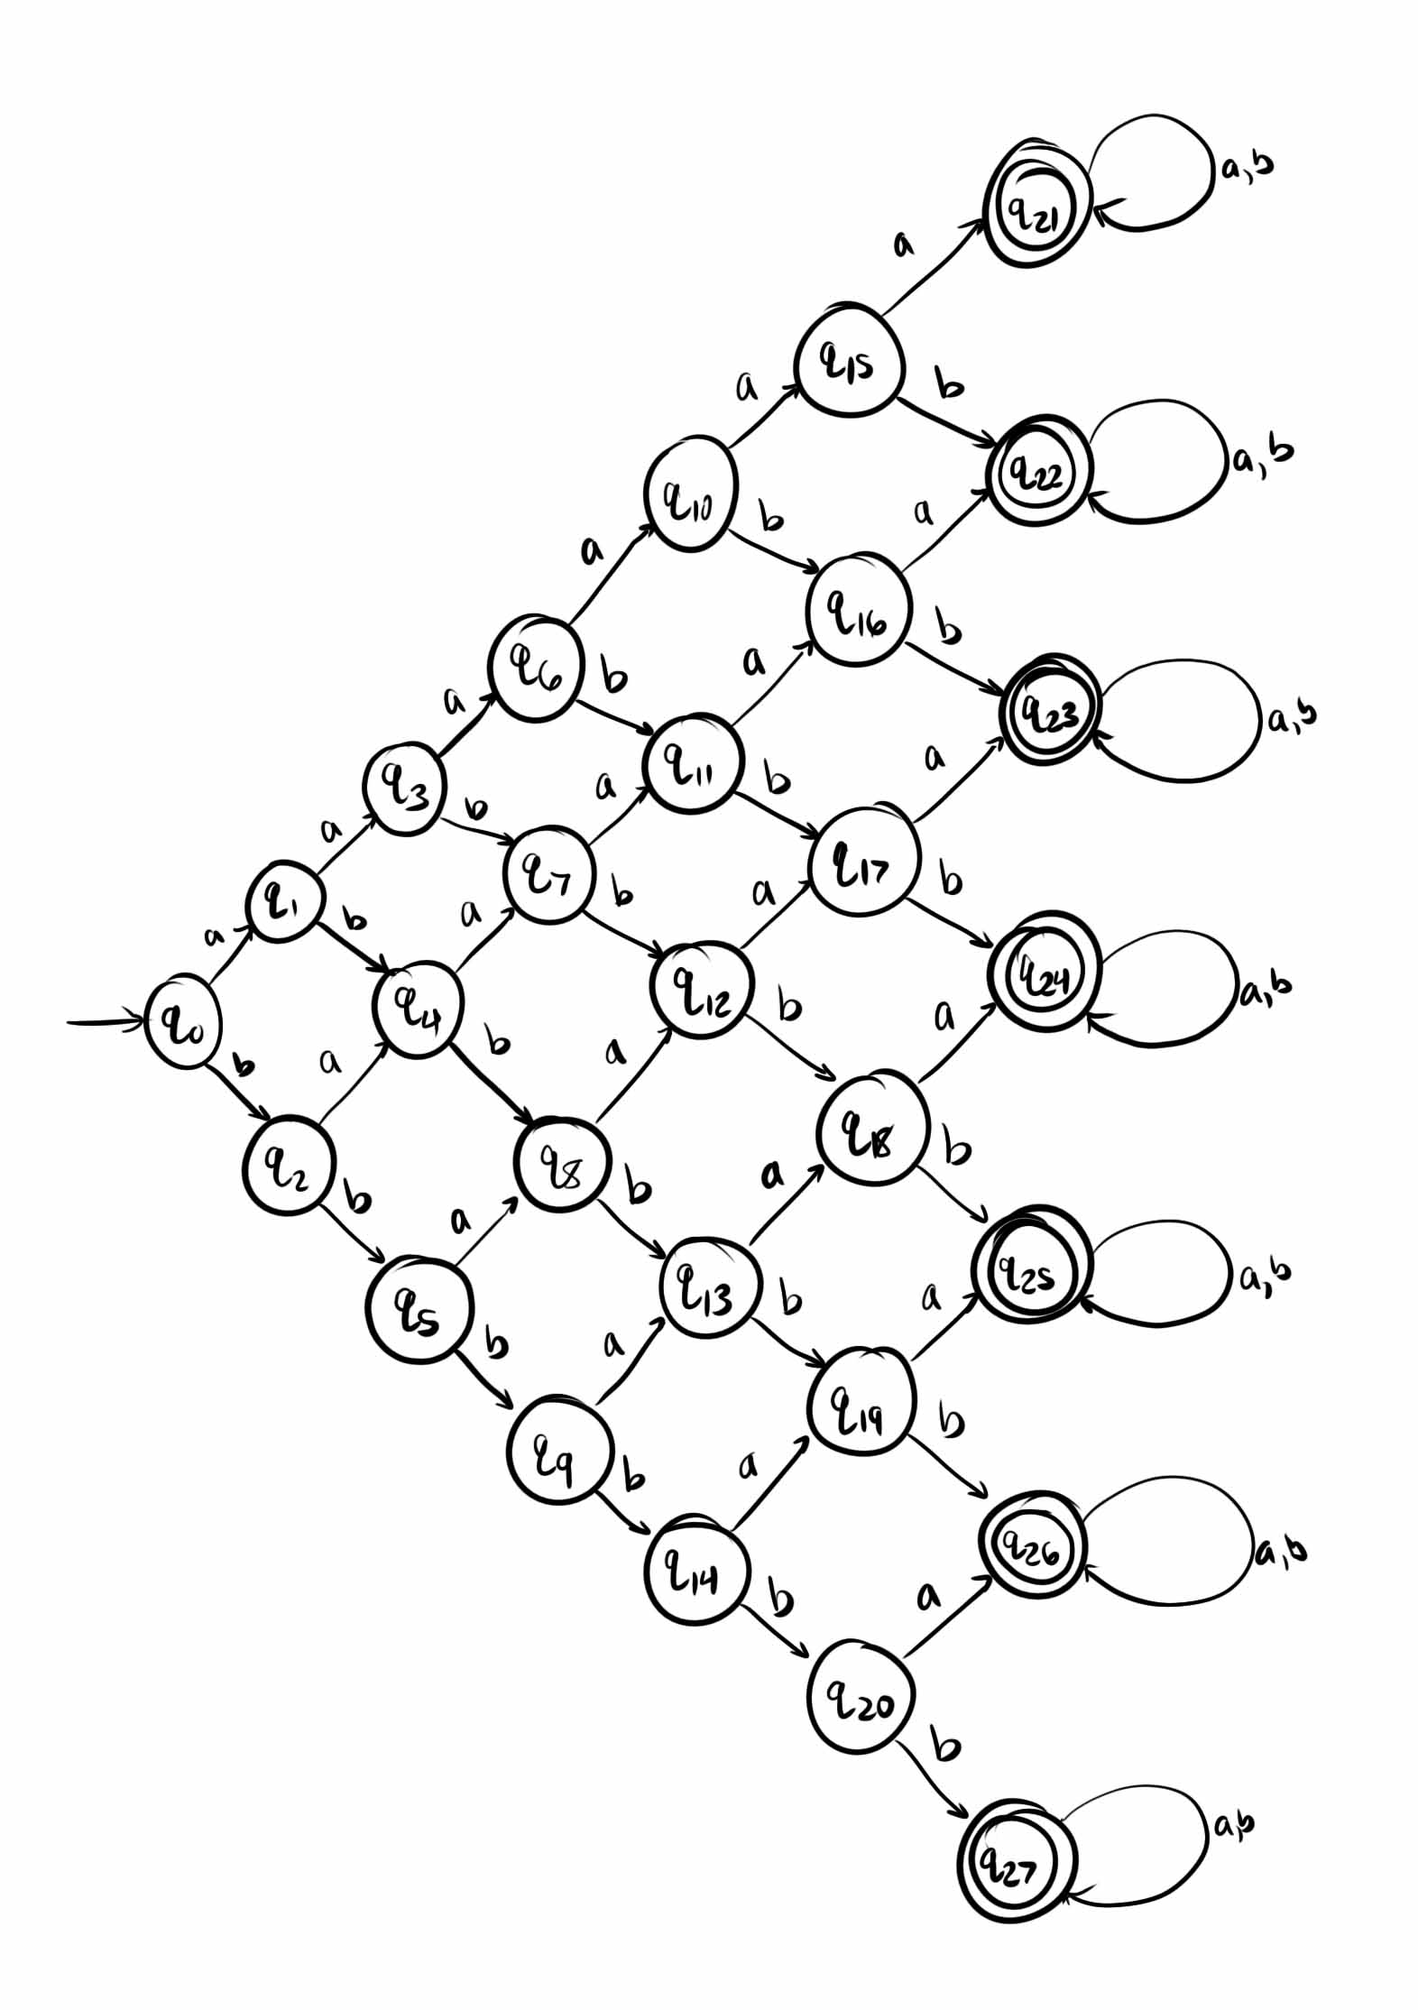

- all strings with an even number of a’s.

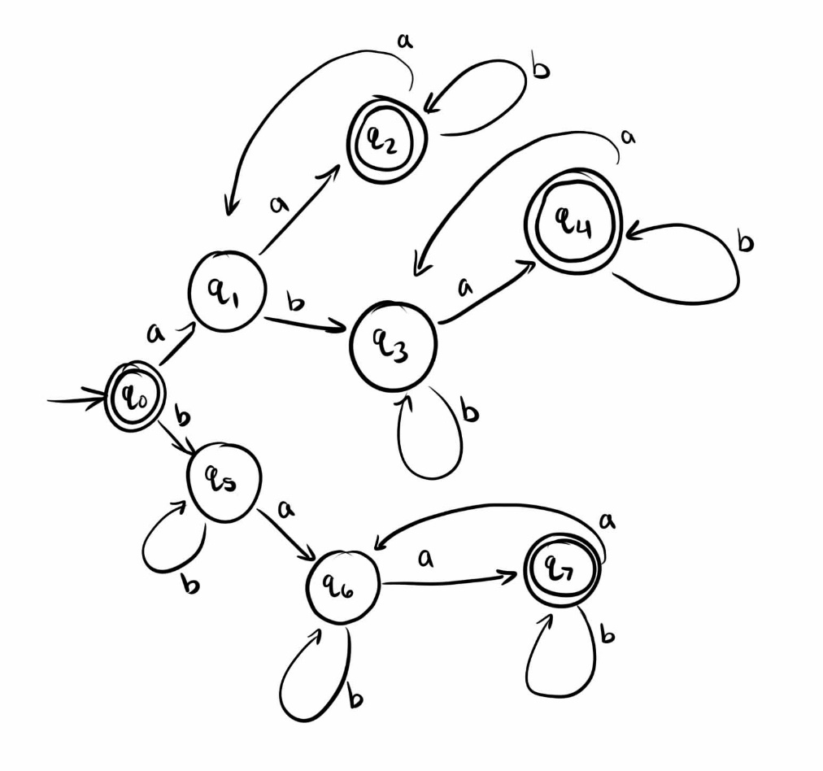

- all strings with an even number of a’s and an odd number of b’s.

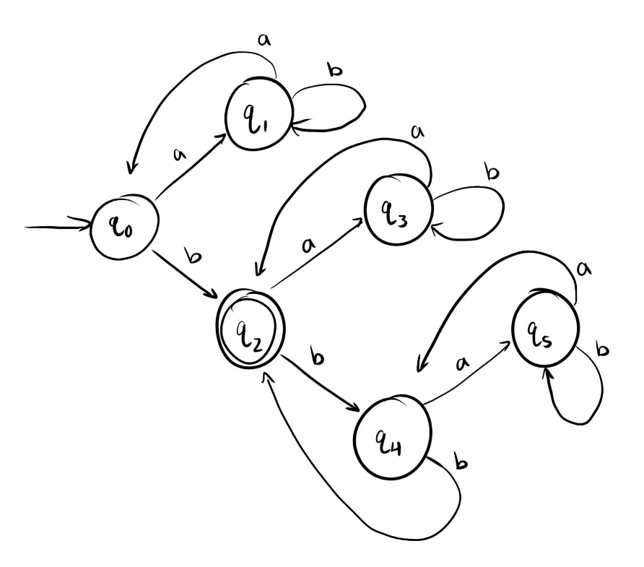
4) d) all strings with at least one b and exactly 2 a’s

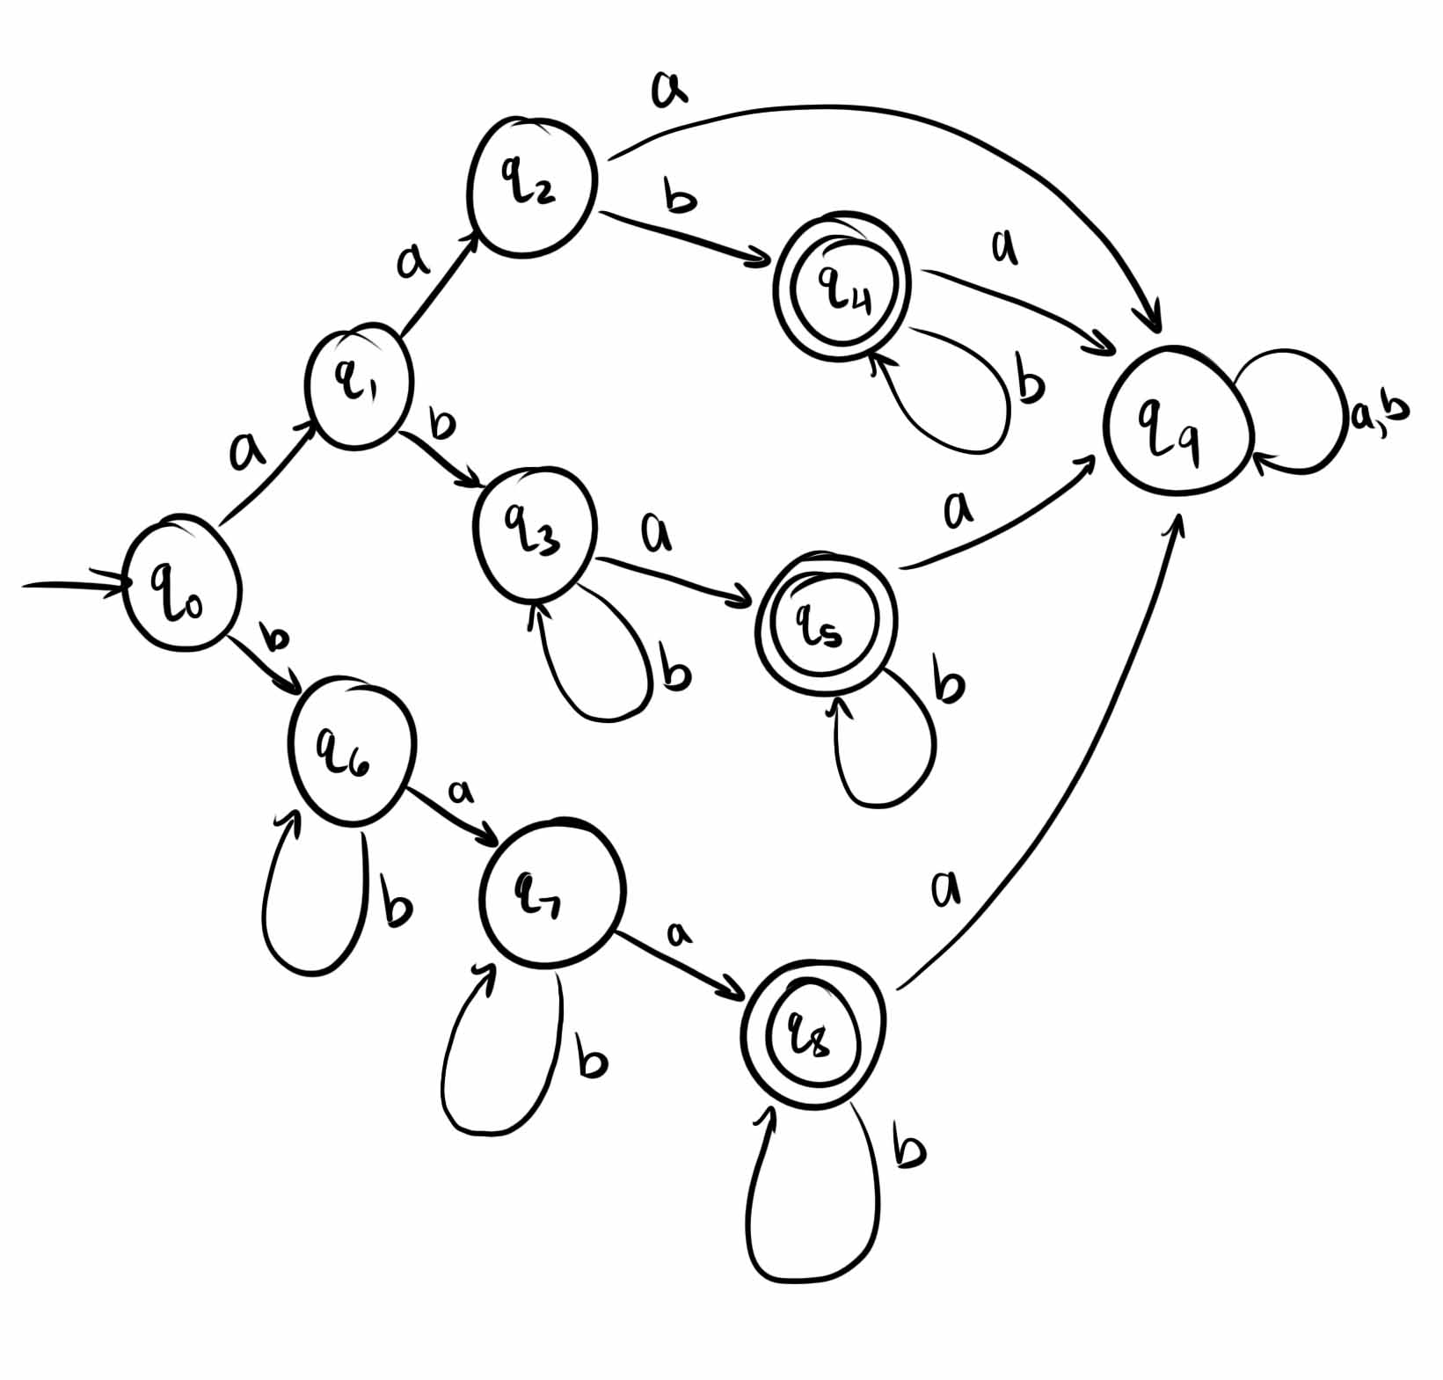

6) With Σ = { a, b }, give a DFA for L = {w1 a w2 : |w1| >= 3, |w2| <= 4 }.

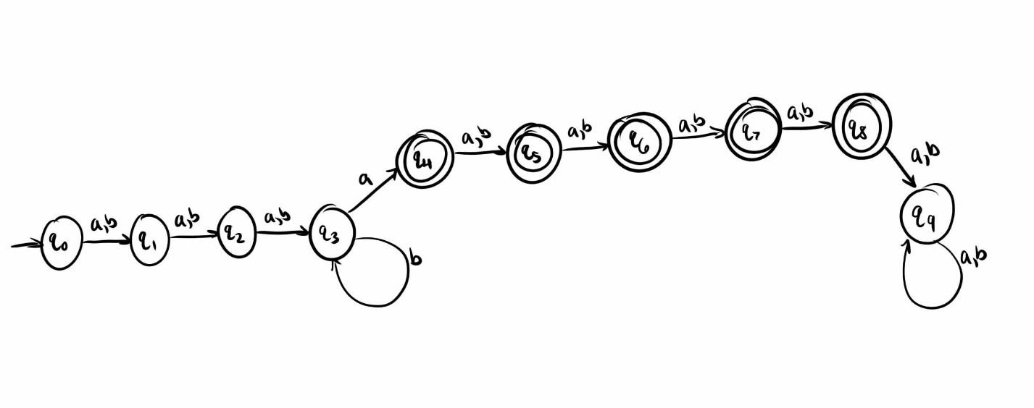

11) Consider the strings on {0, 1}. For each requirement listed, construct an accepting DFA.

- Every 00 is followed immediately by a 1.
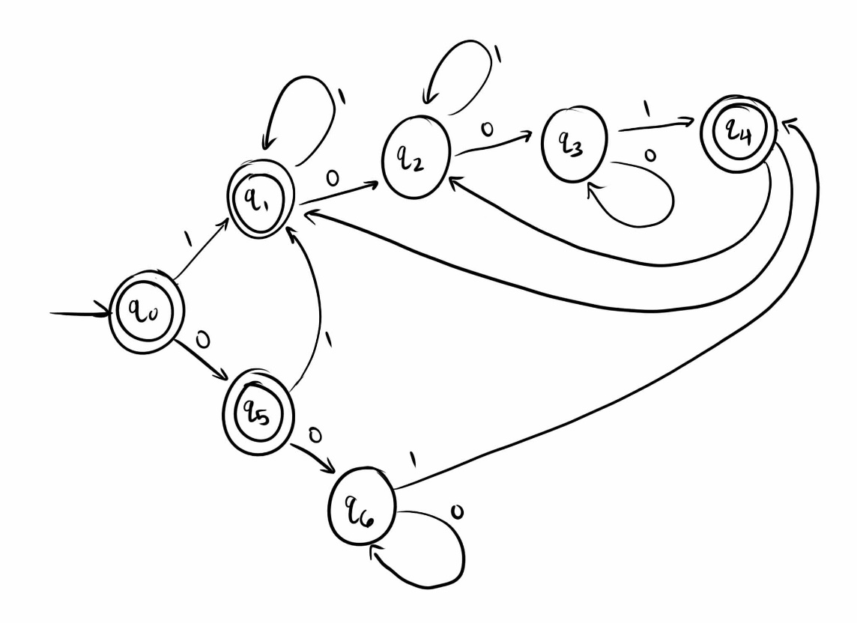

d) Every substring of 4 symbols has, at most, two 0’s.

